RFID Field strength Measurement Tag

Tijmen Verhulsdonck, Dhananjay Kittur, Binayak Ghosh

Contact Details:

(Tijmen) [tijmen@kth.se](mailto:tijmen@kth.se)

(Dhananjay)[dkkg@kth.se](mailto:dkkg@kth.se)

(Binayak)[binayak@kth.se](mailto:binayak@kth.se)

26-09-2016

# Description

The goal of this project is to create an integrated solution to measure the field strength and direction of an rfid reader antenna and present the data in a comprehensive method. This is achieved through a setup of 3 charge level indicators measuring the field strength, and a microcontroller to convert the analog levels to digital data and send it to a pc for processing.

An RFID reader will be used to power the antenna and generate a field, and will also be used to receive the data from the microcontroller. The data from the RFID reader will be processed on a connected computer and combined with pre-determined spatial data to form a 3D graphic with information about the magnetic field.

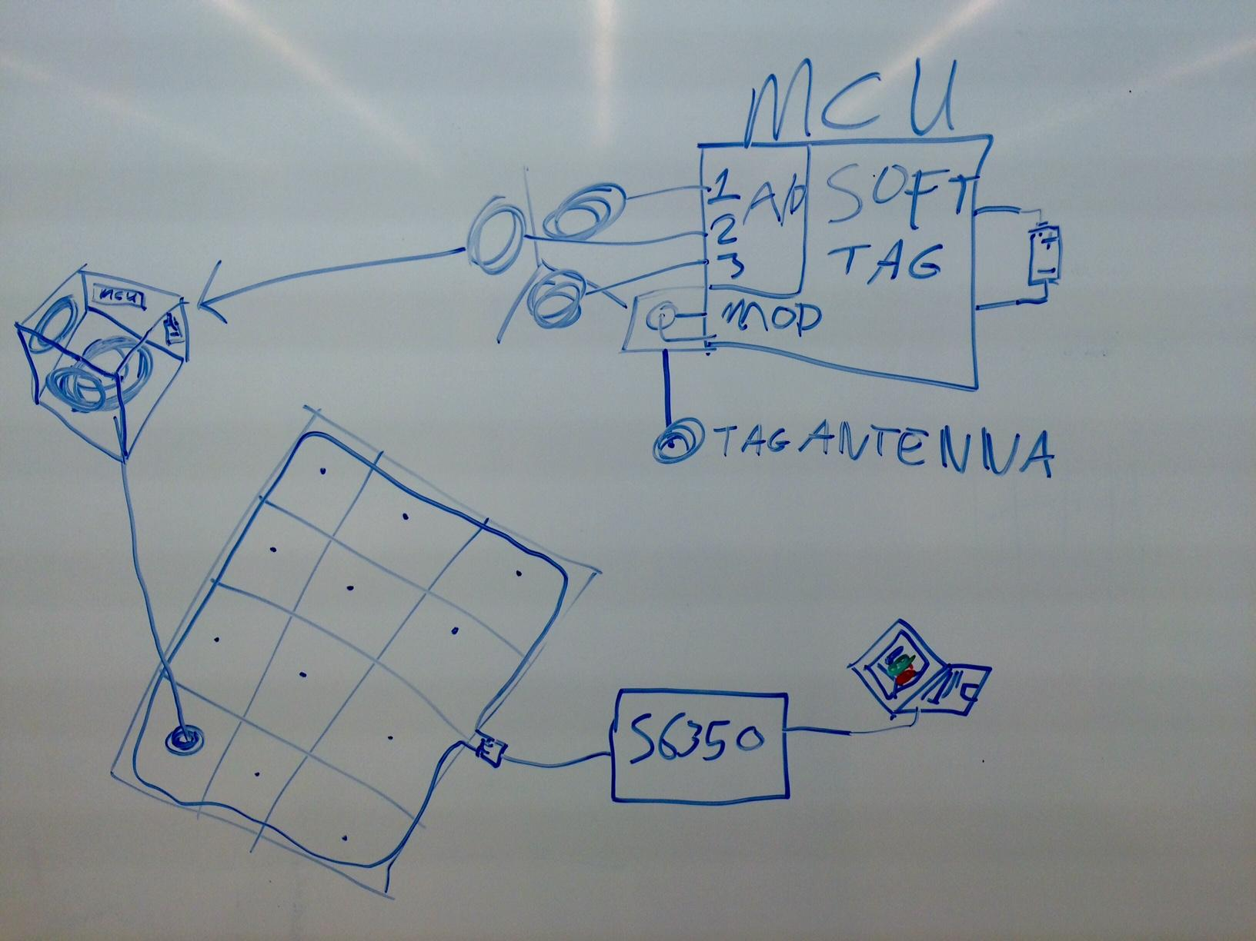

# 

# 

Figure 1: Graphic representation of the system

# Value to Society

Whenever someone designs an antenna for rfid it will have different magnetic field characteristics.There are expensive tools to measure this accurately in an anechoic chamber, but these are out of reach for students and require a lot of time to set up. Our solution would be able to give a quick rough estimate of the magnetic field and is available to students to use for educational purposes.

# Resources

### Microcontroller

We have decided to use the Prototype Kit Cypress Semiconductor CY8CKIT-049-42XX since it is cheaply available and the configurable analog blocks could eliminate some of the external analog circuitry necessary for signal conditioning.

### RFID Reader & Antenna

The antenna constructed by us will be connected to the RFID reader module S6350 and will function as a complete RFID reader which will read the values of the voltages measured from the soft tag.

### Measurement circuit & antenna’s

The measurement circuit consists of the three dimensional RFID tag and the microcontroller. The microcontroller will be used as a voltmeter to read and store the voltage values measured from the tag with the help of a voltage divider circuit.

### Modulation Circuit

The modulation circuit consists of a coaxial cable, which will be used as an antenna to send the voltage values to the reader.

### Power circuit

The power circuit is required to power the microcontroller, we are trying to incorporate energy harvesting in order to reuse that energy to run the microcontroller.

### Enclosure and physical height scale

We are contemplating to attach a mechanical scale to the tag, which is easily movable and can be fixed at any length as need for measuring the height.

# Tasks

Create measuring antenna

Select suitable microcontroller

Create graphics tool

Design measurement circuit

Design modulation circuit & Antenna

Program Soft-Tag

Interface graphics tool and reader

Test measurement and data transfer system

Identify Suitable power source

Create enclosure on laser cutter

Create mechanical height scale

Gantt chart :

<https://app.ganttpro.com/shared/token/f08523398b48a7694b1952f7832a6ee0773f572e8089c5b13cc5f9eeebbba299>

# Roles

## Software Graphics & Reader Interface(Dhananjay)

Dhananjay is responsible for creating the graphics tool using python and/or MATLAB to plot the 3D field strength across the antenna is all the 3 positions. Here we are going to try with the in built libraries first build the graphing tool and if required we are going to modify the available libraries to suit our plot requirements. Dhananjay is also responsible for the reading the data from the reader and integrating the data with graphing tool developed.

## Measurement Circuit & Program (Binayak)

Binayak is responsible for developing a voltage measuring circuit using the microcontroller to measure the voltage values from the three orientations of the tag. The voltage values will be be stored in the microcontroller and then the values will be sent to the RFID reader.

## Soft tag Circuit & Program (Tijmen)

Tijmen is responsible for designing the passive modulation circuit and tag antenna to communicate with the RFID reader. He will also develop the program that will run on the MCU to transfer the data from the A/D Converters to the RFID reader to be processed on the laptop.